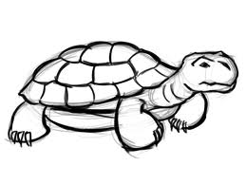______________________________________________________________________________________________________________________



BOTH